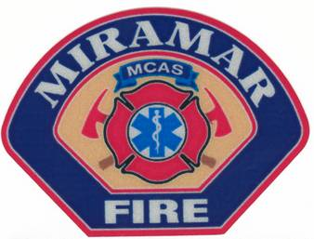
FIRE PERMIT - BARBECUE

MCAS MIRAMAR FIRE DEPARTMENT

FIRE PREVENTION BUREAU

Applicants should fill out entire permit and sign before submission. Signing binds the applicant to abide by all the conditions and requirements listed. Please submit at least 5 days prior to the event.

Organization/Group: Permit #:
Date Permit Issued: Effective Date(s) of Permit:
Location Site of BBQ:
Responsible Party’s Name: Phone #:
Permit Received by: Phone #:
Signature: ________________________________________________________________________________ CONDITIONS AND REQUIREMENTS:
1. Safety Requirements:
- Propane and charcoal BBQ grills shall only be used outdoors.
- The grill shall NOT be located within (10) ten feet of combustible walls, roofs, eaves, overhanging branches, or within twenty (20) feet of a building air intake, door, window or any openings.
- Keep children and pets away from the grill area.
- Keep your grill clean by removing grease or fat buildup from the grills and in trays below the grill.
- Never leave your grill unattended.
2. Provide a fire extinguisher with a rating of 2-A:10-B:C or higher for each BBQ location or a hose connected to a water supply.
3. Charcoal grills:
- If you use a starter fluid, use only charcoal starter fluid. Never add charcoal fluid or any other flammable liquids to the fire.
- Keep charcoal fluid out of the reach of children and away from heat sources.
- When finished cooking, you may leave the coals in the barbecue until completely cooled (48 hours is recommended) OR place the briquettes in a bucket of water before discarding them. Ensure the coals are cold to the touch before discarding them in any dumpster.
4. Propane grills:
- Ensure the propane is in good working order. Check the gas tank hose for leaks and the tank for rust before use.
- Only the new propane gas tanks with an “over-fill” prevention device will be used.
- When not in use store the propane tank properly. DO NOT store propane tanks in Flammable/Combustible storage lockers or buildings.
5. This permit is to be used for the above date(s) and activity only.
6. Area is to be restored to its original condition following the event.
Shaded Area for Fire Prevention Bureau Use Only:
Issued By: |  | Title:
Signature: |  | Phone:
For general information, contact the Fire Prevention Bureau:
7209 Gonsalves Ave, San Diego, CA 92145
858-577-1962 (Office)/858-577-6535 (FAX)

